School District 64 COVID-19
Mandatory Protocols - Worksite Site Procedures

On March 17, 2020 the British Columbia government declared a provincial state of emergency to support the province wide response to the novel coronavirus (COVID-19) pandemic.

The primary directive from the Federal and BC Provincial governments is aimed at limiting potential exposure of Canadians to COVID-19. Employees are to review operations and take preventative measures to ensure physical distancing and appropriate COVID-19 hygiene measures. These new protocols are intended to reduce the exposure of you and your colleagues to the virus and ensure a safe workplace. We are all working together to provide continuity of education to our students and support our communities in a rapidly changing period. This rapidly shifting situation can be stressful, as we work together, let’s lead with common sense, kindness and patience.

School District 64 is requesting staff to begin the following operational arrangements.
COVID-19 Preventative Measures

- Wash your hands often with soap and water for at least 20 seconds, especially after blowing your nose, coughing, or sneezing; going to the bathroom; and before eating or preparing food.
- Maintain physical distancing of six feet/two metres between yourself and others.
- If you have to cough or sneeze, try to do it into your elbow or a tissue, and then throw out the tissue if used and wash your hands afterwards.
- Avoid touching your eyes, nose, and mouth with unwashed hands.
- Stay home when you are sick. If you have a fever, a new cough or are having difficulty breathing, call 8-1-1 and inform your supervisor.
- Avoid close contact with people who are sick.
- Clean and disinfect frequently touched objects and surfaces.
- If you have questions about whether or not you should be tested for COVID-19, use the BC COVID-19 Self-Assessment Tool -https://bc.thrive.health/covid19.




Onsite Work Hours/Access

- Staff will coordinate worksite attendance with their principal or supervisor. Please contact your principal or supervisor as they develop a building access and schedule and work to determine individual’s access needs.
- Use the designated entrance(s) and exit(s).
- Schools will lock their doors during the day to limit public access.

Entering/Leaving the Building

- Maintain safe physical distancing guidelines of six feet/two meters between people when entering and leaving the building. Do not enter or leave the building in groups!
- Each school will develop protocols for entry and exit specific to the building’s layout.
- Wash your hands after you enter the building and disinfect your workspace as needed.

If your principal or supervisor determines that all or specific components of your duties are required to by performed from on-site, please adhere to the following requirements when in district buildings.
Daily Sanitizing Routines

- Wash your hands when you arrive at work.
- Disinfect your work area as needed.
- If you must meet in an alternate space (as identified by your administration), disinfect the used, surfaces, furniture, equipment etc. after the meeting.
- Disinfect all shared surfaces, furniture equipment etc. when finished.
- Do not share food/drinks.
Daily Communication Routines

- When you arrive at your worksite, head straight to your work location.
- Call, email or verbally check in with your supervisor or designated person and let them know you are there.
- Call or email your administrator with any questions throughout the day.
- Check your email regularly for updates.
- Call, email or verbally check in with your supervisor or designated person when you are leaving the building at the end of the day.

Physical Distancing

- Follow safe physical distancing guidelines of maintaining 6 ft or two metres distance between people at all times.
- Work in your classroom, office or workspace as much as possible.
- If you need to talk to someone, make sure you stay six feet or two metres away or use your phone to contact them.
- The capacity of a room is determined by ensuring at least six feet/two metres can be easily maintained in a circle around all individuals.
- Use the phone, Microsoft teams, Zoom, Facetime, text, etc as much as possible.
Shared Equipment and Common Spaces

- If you need to use shared equipment wash your hands before you begin.
- When you are finished, disinfect the equipment.
- Disinfect any shared surfaces or equipment such as photocopiers, staplers, hole punches, etc that you used.
- Only one person is allowed to use the shared equipment at a time.
- When you are finished using the common space or equipment, wash your hands again before you go back to your office or workspace.

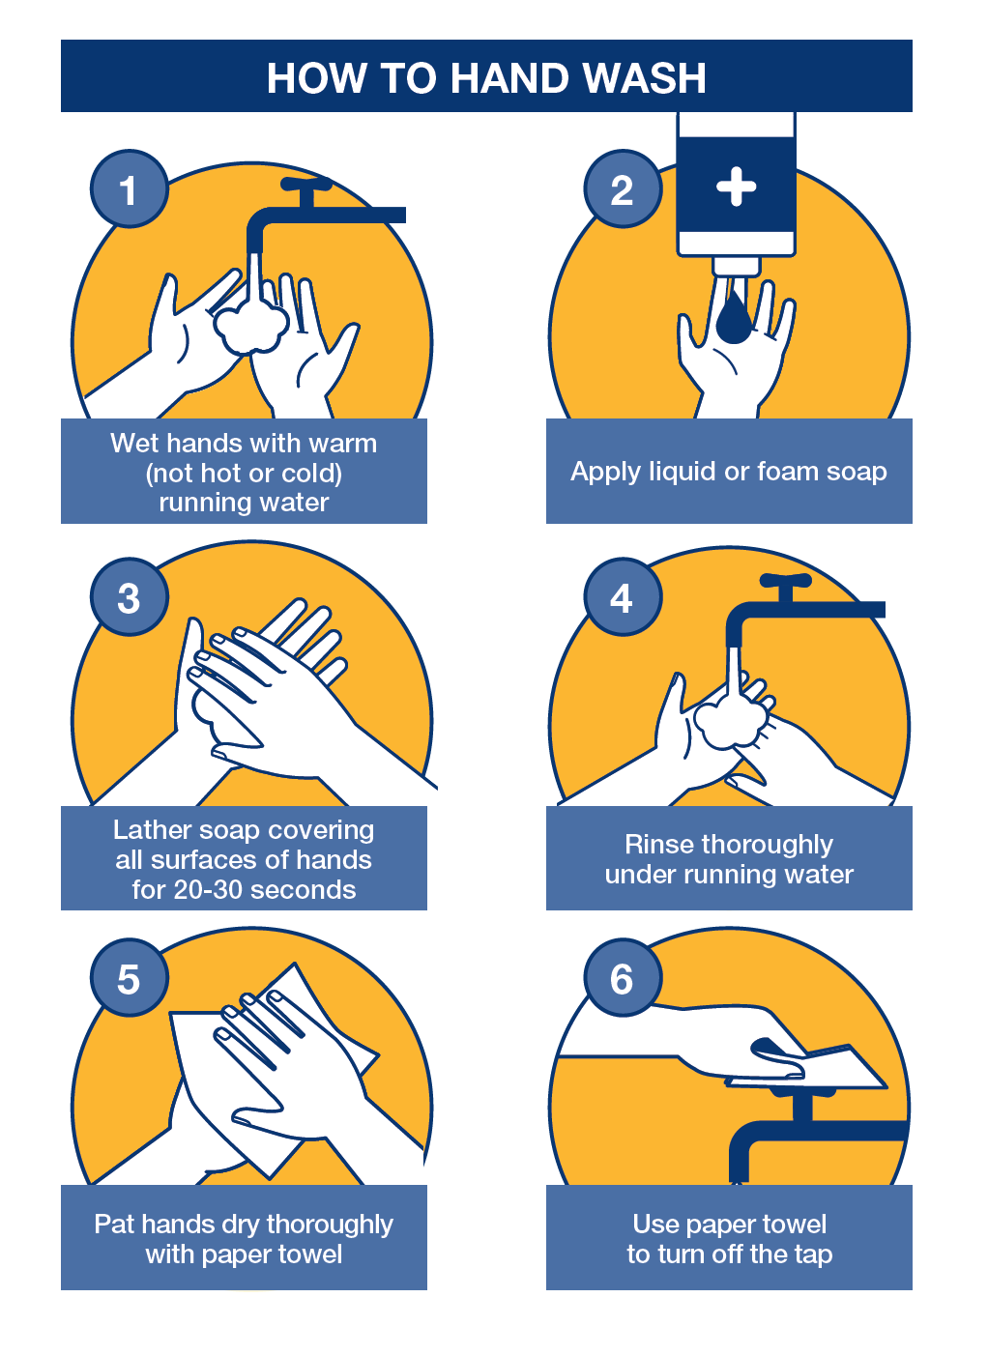

Break Rooms

- Wash your hands before you go into break rooms.
- The break room will not be available for eating. It can be used for food storage, accessing appliances, etc.
- Disinfect the areas, surfaces, appliances, etc. that you use in the break room.
- When you are finished wash your hands again before you go back to your classroom, office or workspace.
- Do not share food or drink.

Other Shared or Speciality Spaces

- Administrators will develop protocols for use of other shared spaces within their individual buildings (libraries, gyms, shops, etc.).
- Protocols for these spaces must be in line with district protocols.
Illness

- If you are sick, stay home and let your supervisor know.
- If you start to develop symptoms while at work, let your supervisor know via email or phone and go home.
- If you are not sure whether you should stay home use the self -assessment tool at https://bc.thrive.health/covid19

Know the Facts

Using reliable sources of information will ensure that what you do learn is fact, not fear-based.

The BC Centre For Disease Control:
http://covid-19.bccdc.ca/

Health Link BC: https://www.healthlinkbc.ca/health-feature/coronavirus-disease-covid-19

Health Canada:
https://www.canada.ca/en/public-health/services/diseases/coronavirus-disease-covid-19.html

The World Health Organization: https://www.canada.ca/en/public-health/services/diseases/coronavirus-disease-covid-19.html

Mental Well-being

Build self-care into your day. All the things you do to take care of yourself will help manage your stress. And by taking good care of yourself, you’ll be better prepared to take care of others. Some mental wellness ideas:
- Meditate / Practice deep breathing
- Play a board game or cards
- Phone or digitally connected with friends and family
- Read about something other than the virus
- Start a digital detox (leave your phone alone for a while)
- Exercise – indoors or outdoors
- Learn a new recipe or skill
Call 1-888-COVID-19 or text 604-630-0300 for details, advice, and further information on the virus in British Columbia.

Sited From: https://www2.gov.bc.ca/gov/content/governments/organizational-structure/ministries-organizations/ministries/mental-health-addictions

